**Vrinda Store Analysis**

Vrinda Stores aimed to generate a yearly sales report for the year 2022 in order to gain insights into their customer base and enhance sales growth in 2023. They have provided us with an Excel spreadsheet containing the data, and our task is to analyse and visually represent the information within the spreadsheet.

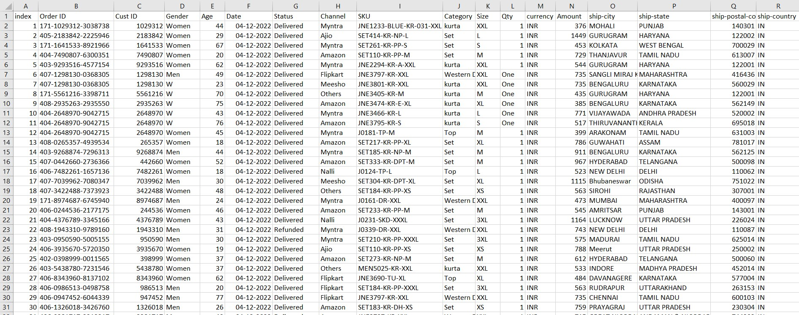Let’s proceed to see our original dataset,

Data Cleansing Steps:

In order to clean the data, we need to perform the following tasks:

1. Standardize the gender column:

- Update instances of 'M' to 'Male' and 'W' to 'Women' for consistency.

2. Create a separate age group column using nested IF formulas:

- Use nested IF formulas to categorize ages into Adult, Senior, and Teenager groups. This step is necessary as working with the age column directly might not provide meaningful visualizations.



.

3. Split the month from the date column:

- Extract the month from the date column to create a separate column specifically for the month values. This will enable better analysis and visualization of monthly sales data.



4. Replace 'One' and 'Two' with 1 and 2 in the Qty column and ‘W’ with Women in Gender column:

- Update occurrences of 'One' with 1 and 'Two' with 2 in the Qty column. This ensures consistent numerical values for quantity measurements.

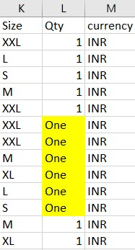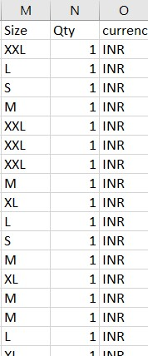

- Update occurrences of 'W' with Women in Gender column.

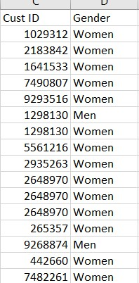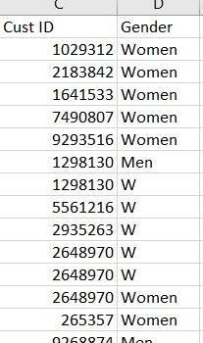

By performing these data cleansing steps, we can ensure the data is standardized, categorized appropriately, and ready for further analysis and visualization.\

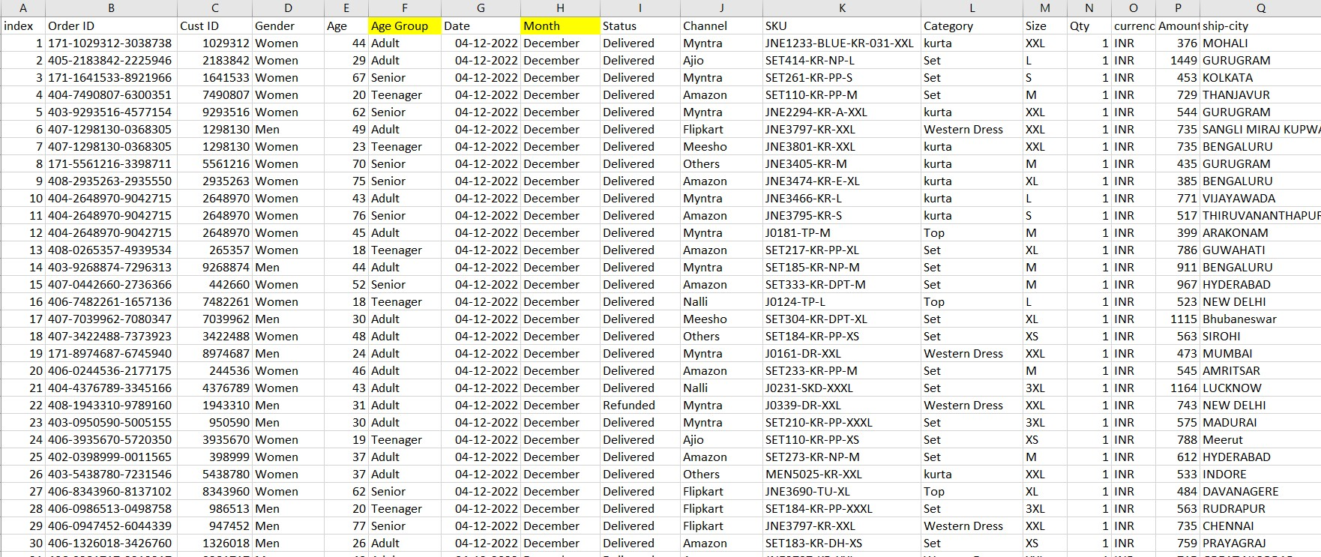Here is the dataset after applying the data cleansing steps:

The gender column has been standardized, with 'M' and 'W' replaced with 'Male' and 'Women' respectively. An additional column, Age Group, has been created using nested IF formulas to categorize ages into Adult, Senior, and Teenager groups. The month has been extracted from the date column and placed in a separate column for better analysis. Lastly, the 'Qty' column has been updated, replacing 'One' with 1 and 'Two' with 2 to ensure consistent numerical values for quantity measurements.

The cleaned dataset is now ready for further analysis and visualization.

**Pivoting Data:**

1. Which month had the highest sales and orders, and can you provide a single chart to compare the sales and orders data?

From the above chart, the month of March had the highest sales with a total of 1.92 million units sold. Additionally, March also had the highest number of orders, with a total of 2,819 orders placed. This indicates that March was a particularly successful month in terms of both sales volume and order activity.

1. In 2022, which group made more purchases: men or women?

In 2022, women accounted for 64% of the total purchases made, while men made up the remaining 36%. This indicates that women made a larger proportion of purchases compared to men during that year.

1. What are the various order statuses observed in 2022?

Based on the doughnut chart provided, we can observe that there are four distinct order statuses in 2022: Cancelled, Delivered, Refunded, and Returned. Among these statuses, the majority of orders, constituting approximately 92%, have been marked as Delivered.

1. Which are the top 5 states that have the highest contribution to sales?

The top 5 states that have the highest contribution to sales are as follows:

1. Maharashtra: Sales contribution of 2.99 million units

2. Karnataka: Sales contribution of 2.65 million units

3. Uttar Pradesh (UP): Sales contribution of 2.10 million units

4. Telangana: Sales contribution of 1.71 million units

5. Tamil Nadu: Sales contribution of 1.68 million units

These states have demonstrated significant sales contributions, with Maharashtra leading the pack followed by Karnataka, Uttar Pradesh, Telangana, and Tamil Nadu.

1. How is age related to gender?

Upon analysis, it is evident that the age group of adults between 24 and 49 years makes the highest contribution to sales. Among this age group, women account for 45.38% of the sales, while men contribute 20.07%. This indicates that the adult age group, particularly women within that range, significantly drives sales.

1. Which channel is making the highest contribution to sales?

According to the pie chart provided, it is clear that out of the various channels utilized by the store, Amazon, Myntra, and Flipkart make the highest contributions to sales. Amazon accounts for 35% of the sales, followed by Myntra at 23% and Flipkart at 22%. These three channels prove to be the primary drivers of sales for the store, highlighting their significant impact on the overall sales performance.

After conducting various analyses, including pivot tables and visualizations, all the generated visualizations have been incorporated into the previously created report sheet. Additionally, slicers have been added to enable filtered viewing of the visualizations.

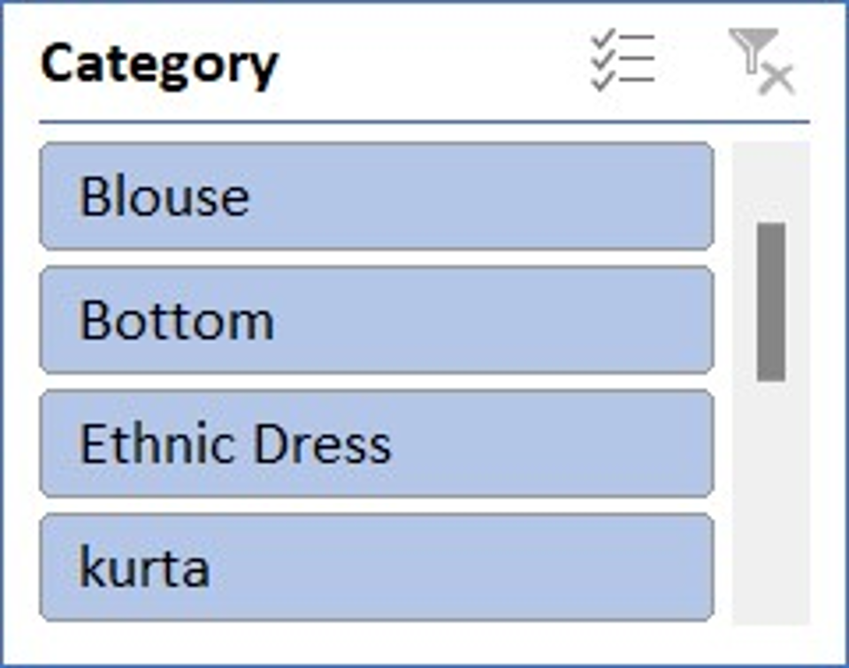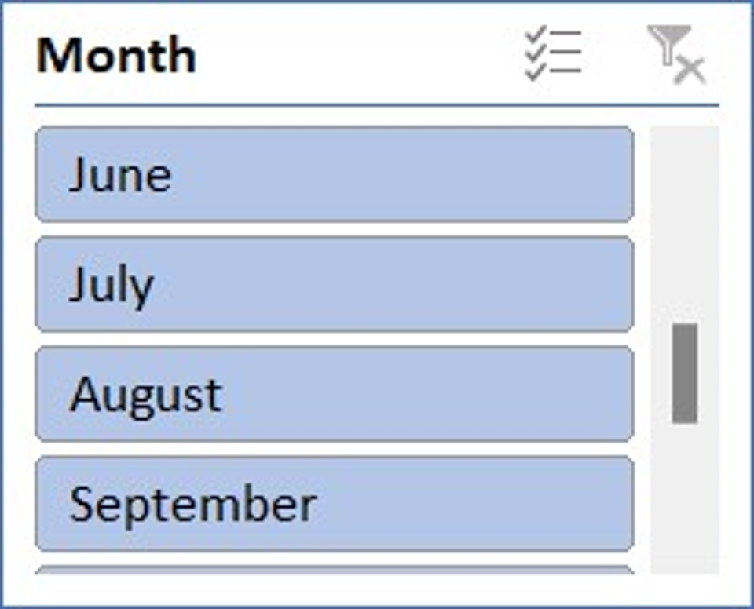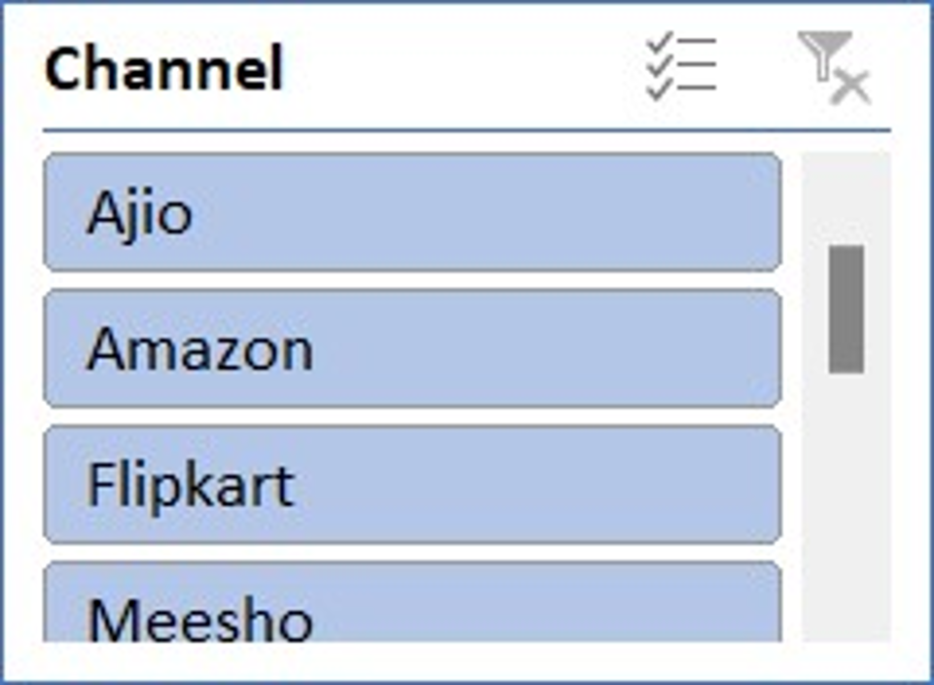To add slicers, the process involves selecting a visual and accessing the "insert slicers" option. From there, specific columns, such as month, category, and channel, can be chosen to create the desired slicers. The slicers, along with the visualizations, are organized on the sheet to ensure a cohesive layout.

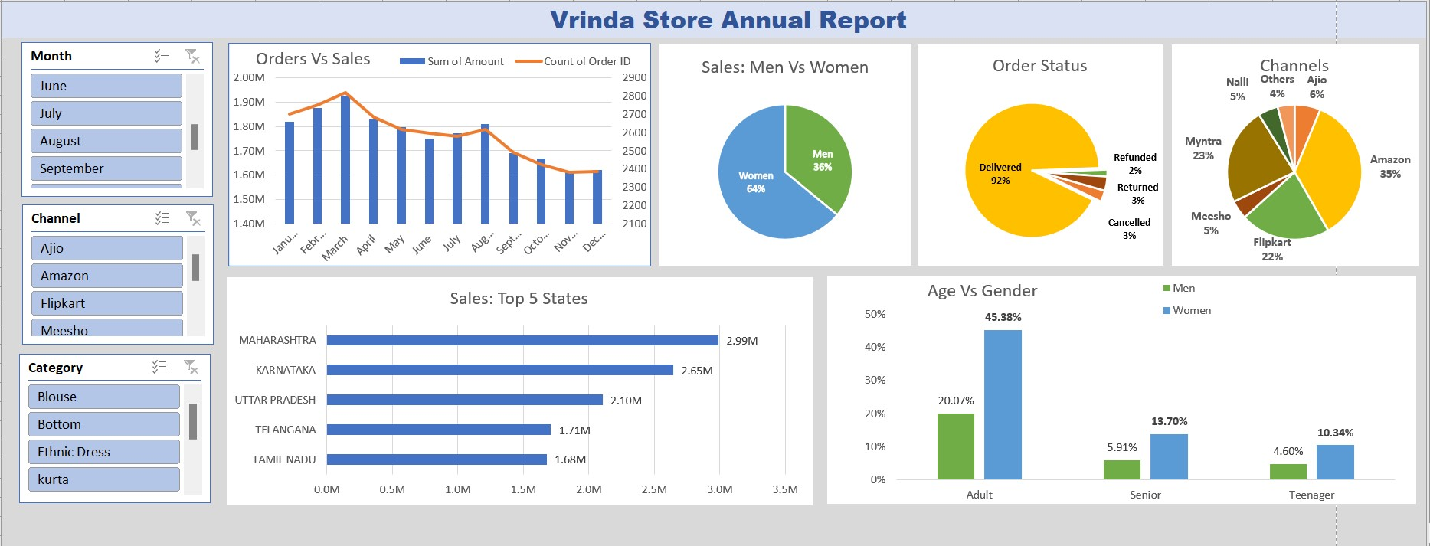Finally, the comprehensive report, titled "Vrinda Stores Annual Report 2022," is now complete. To provide reference, a sample report has been included as an example. By referring to the report, stakeholders can access the visualizations, apply slicer filters, and gain insights into the data. For documentation purposes, the report can also be exported as a PDF for convenient sharing and distribution.